#
# 20210405
# I added my public ssh keys.
#
https://gitlab.tcsbank.ru/-/profile/keys
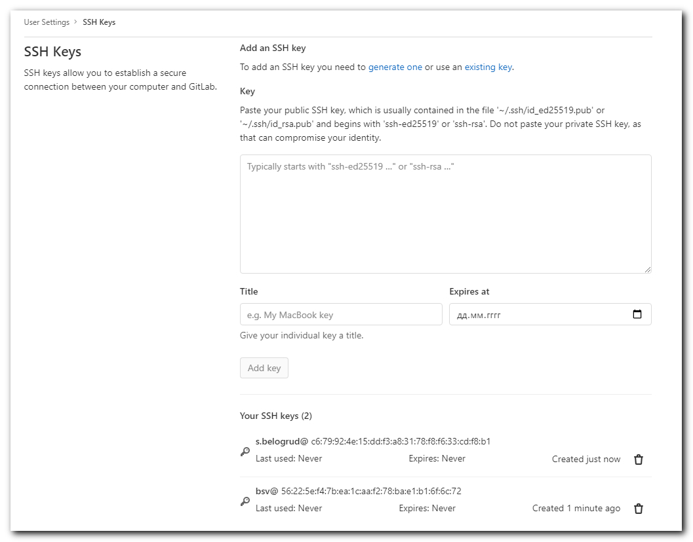

#
# When I connected to public repository, I found follow warning.
#
https://gitlab.tcsbank.ru/ansible-galaxy-roles/tinkoff-ca-certs

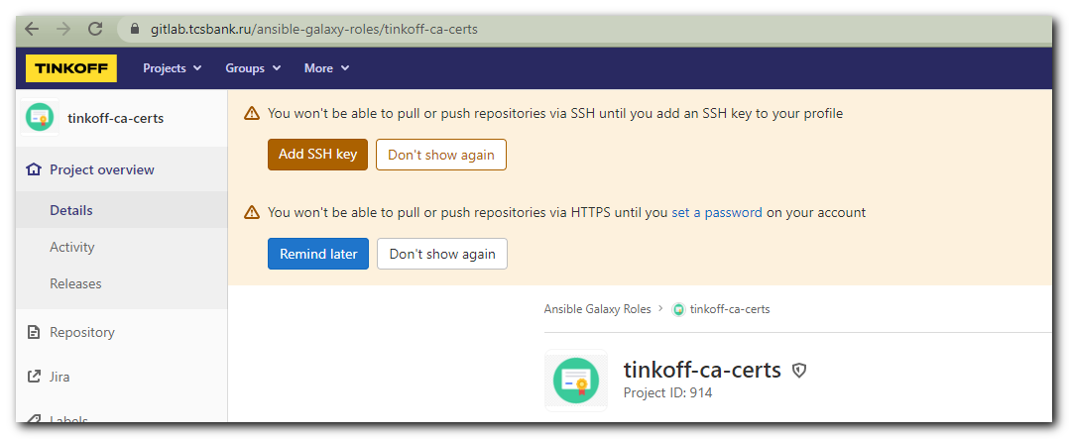
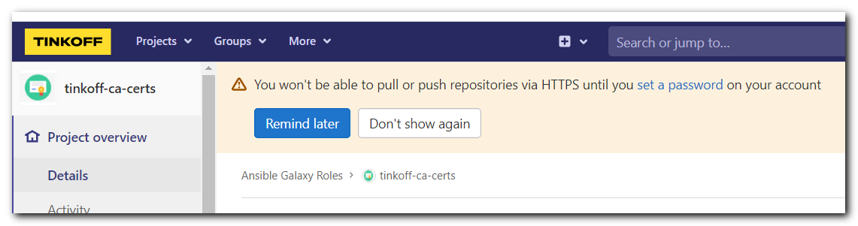

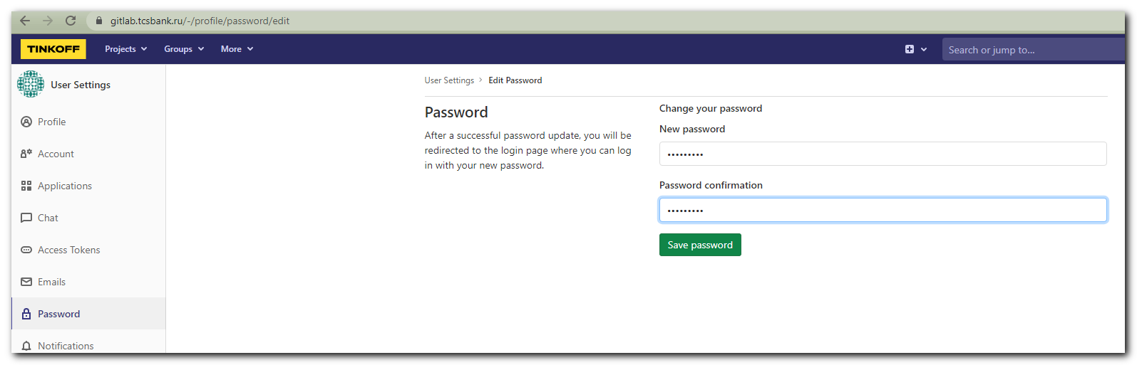

# 20210608
# https://tinkoff.slack.com/archives/C01URFLSJFN/p1623165120055700
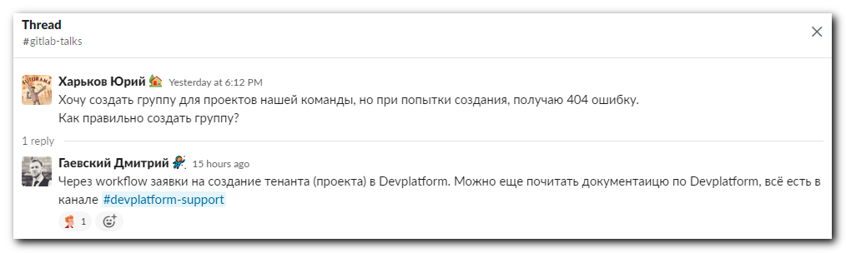

# 20210816
# Here is my experience, how to clone repository from gitlab: 20210816 gitlab repository clamav
# How to connect via ssh and manage it.
#

